Material and Texture Animation With NifSkope:

Part 4: Controller Manager, Sequence and Script
A tutorial from Pixelhate. 2014.
Contact Information: Pm Pixelhate at http://forums.nexusmods.com/index.php?showuser=1205226
This guide is the result of compiling information on the use of NifSkope by reading tutorials (some quite outdated) and Wikis, tracking help posts on forums or by trying to figure things out by myself.
This work was possible thanks to too many people to name them all. Some of their words where just copy/pasted here, as things where explained better than I will ever be able to do.
I am forever grateful for their generous act of sharing knowledge.
So, if this guide is ever useful to you, it is thanks to them.
Please, see credits and links at the end of this document.
This part comes from a package with 4 parts in Pdf or Doc format and with a series of meshes and textures, referenced in the following pages. A series of flow charts images summarize the steps for each animation type.
If you received this tutorial without these resources, please visit http://www.nexusmods.com/fallout3/ and download the full package.
Tutorial is in four parts:
Part 1 an Introduction
Part 2 about Material Animations
Part 3 covering Textures Animations

Part 4 This part which deal with Controller Manager, Sequence and Script.

Table of Content
- Structure
- Step by Step
  - Preparatory Work
  - General Structure Building
  - Sequence Building
  - Building animation blocks within a sequence
  - Duplicating Sequence
  - Setting Time and Keys
- Script
- Troubleshooting check list
- Final Note
- Credits
Thank you to TrickyVein for his inspiring tutorial http://forums.nexusmods.com/index.php?/topic/984792-tutorial-working-with-the-nicontrollermanager/
This tutorial is focused on Static or Havoked object. No skins, armours or weapons have been tested.
All information shared here is meant for Fallout 3, but most probably will work for FNV as well.
Two meshes are provided: a working camera monitor (DemoCameraMonitor.nif) and a “blank” monitor (DemoTerminaInterface01.nif).
The camera monitor contains multiple Material and Texture animations in two sequences that can be triggered by script. It is given for information and inspiration purpose.
The blank monitor is made ready for you to build the animation while following the tutorial.
The nif has three parts that can be animated separately: the Power Button, the Screen and the Glare.
In this demonstration, we will set a simple animation Translate for the Screen and Emissive for the Power Button.
Hopefully, you will be able to animate the other parts by yourself later.
When OFF (Forward) the screen will display one part of the texture fixedly, the button will be unlit.
When ON (Backward) the screen will display a panning effect on another part of the texture, giving the illusion of a security camera recording, the button will be glowing.
Both sequences will use the same animation block structure. In order to save some work the following steps are planned:
- Preparatory work.
- Building the general structure.
- Building one sequence structure.
- Duplicate it at a certain point and set the parameters of the two sequences to differentiate them.
- Integrate them in the general structure.
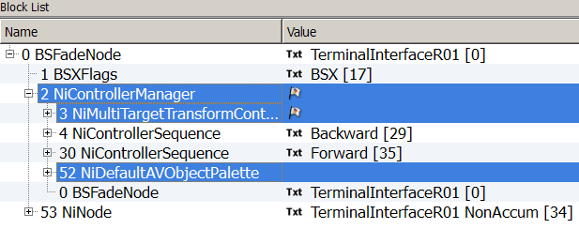
Structure
The architecture for a Material or a Texture Animation with a NiControllerManager is a bit more complex than for regular animations. (Make sure you’ve read and understood part 2 & 3).
Let’s have a brief look at the general structure first.
If we expand the Root Node, a BSXFlags, a NiControllerManager and a NiNode will appear.

The NiControllerManager will be in main control. Attached to it is a NiDefaultAVObjectPalette, referencing all the NiTriStrips and NiNodes contained in you nif.
As next Controller, a NiMultiTargetTranformController also referencing all the NiTriStrips and NiNodes contained in you nif.
Then comes the NiControllerSequence. From one (usually an idle animation) to several depending how many animations the object is supposed to play. The names of the NiControllerSequence are coded to be triggered by scripts.

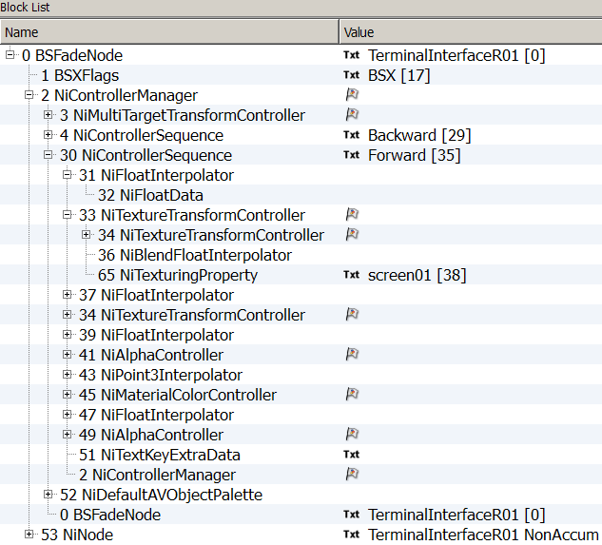
Each NiControllerSequence will have one ore more controlled blocks with the animation blocks build in. Each NiControllerSequence will have a NiTextKeyExtraData where Start and Stop time are defined and sound triggering is possibly set.

A sequence

A Texture Transform animation block

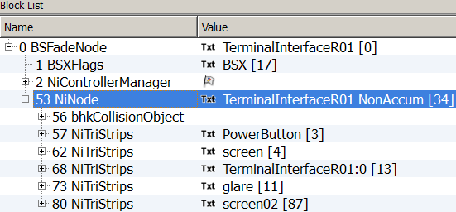
And lastly, attached to the Root Node, the NiNode which will contain all the NiTriStrips and NiNodes from your nif.
To set up this intricate structure, please follow the steps cautiously, as they are given after careful consideration.

Open DemoCameraMonitor.nif, and DemoTerminalInterFace01.nif in Geck preview.
Open both of them in NifSkope and compare them.

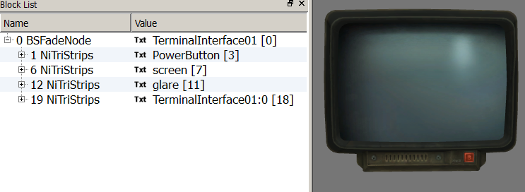
Open DemoTerminalInterFace01.nif
We are going to animate the screen
And the Power Button
Step by Step
Let’s check a few things:
- Is there a BSXFlags? (Collision needs to be activated for player activation detection.)
- Is there any Shader preparatory to do? Better to do it now, if needed. Textures animations need a BSShaderNoLightingProperty.
- Is my future animated NiTriStrips animation ready, is my texture correctly UV sized?
- Are the Material and the Texturing Properties well named?
- Do I have a Collision Object? (Needed for activate triggering.)
Preparatory work
- Inserting a BSXFlag (if not present).

- Block  Insert  Bethesda  BSXFlag.
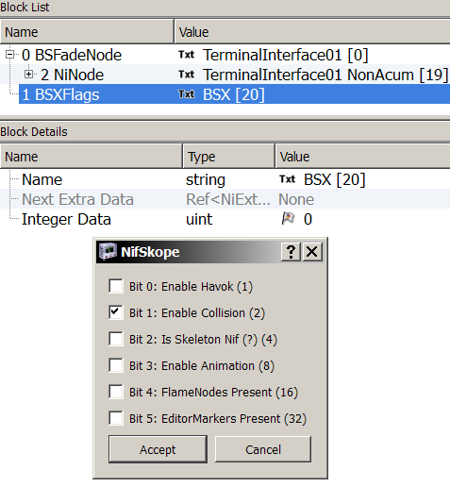
- Click on the flag to access the popup window settings.
Check Bit 1 to enable collision.
1A. Linking the BSXFlag with the Root Node: select the BSFadeNode.
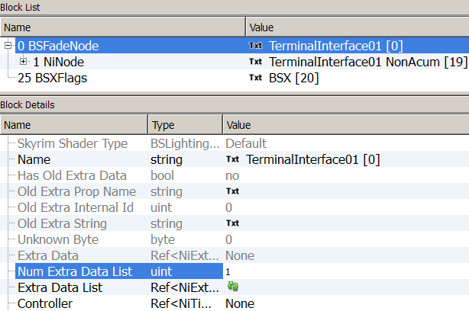
- In Block Details, change the Num Extra Data List to 1, update.
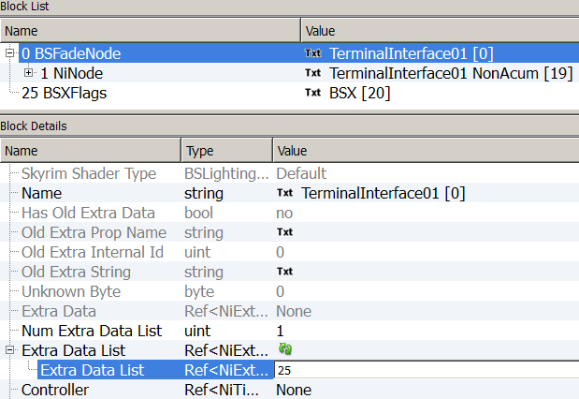
- In Extra Data List Value, enter the value of the BSXFlag.
- Shader preparatory work if needed. (see Part 3, page 2 of the tutorial.)
Luckily, not for this demo.
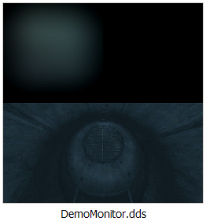
- Texture choice and size setting.
DemoMonitor.dds.

A quarter up left will be used for OFF/Forward

Half for Panning effect ON/Backward
The UV map needs to be resized half of its size.

3A. Find the NiSourceTexture of the Screen NiTriStrips. Select the texture (click on mauve flower).
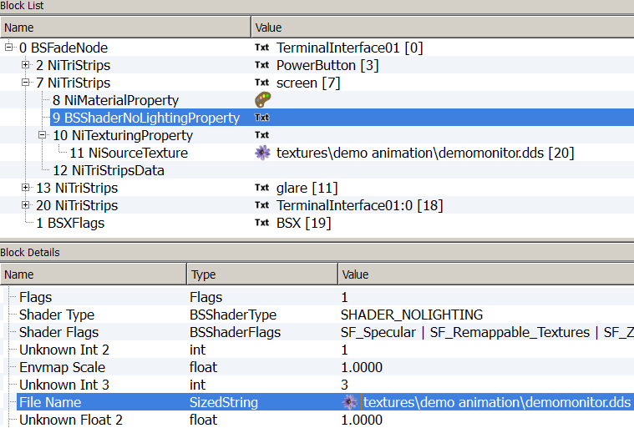
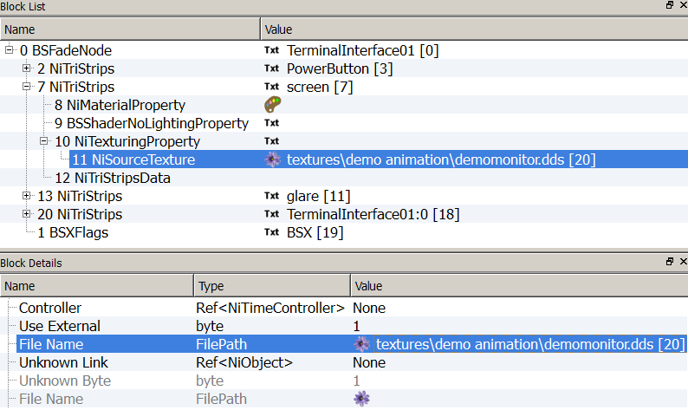
3B. Select the same texture in the BSShaderNoLightingProperty of the Screen NiTriStrips (mauve flower in File Name).

3C. Enabling textures animation and retiling the UV map half of its size.
In NiTexturingProperty, expand the Base Texture:
- Select Yes for the Has Texture Transform Value. This is a switch for animations.
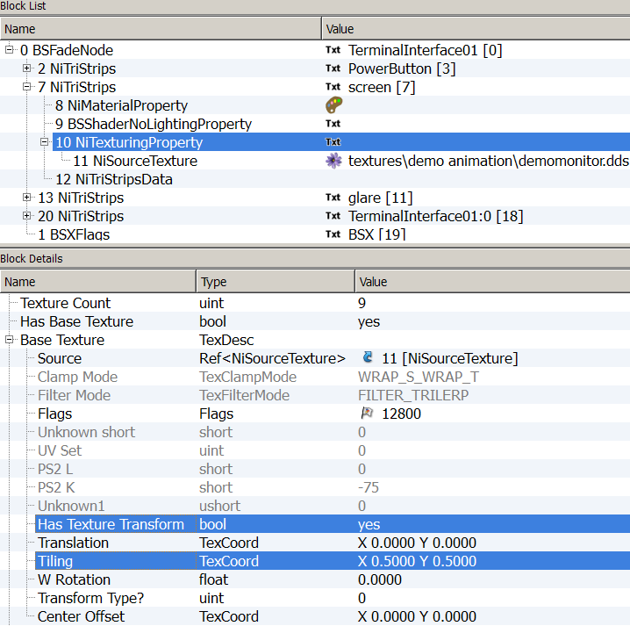
- Enter 0.5000 to both Tiling Value.
- Give the NiMaterialProperty and the NiTexturingProperty of the NiTriStrips screen a proper name.
- Do the same with the all Material and Texture Properties of the NiTriStrips you plan to animate.
- Create a Collision Object if needed.

You can save at this point and see in Geck preview if everything is fine, so far.
This close the preparatory work, now, we can start the:
General structure building
We want all the NiTriStrips to be gathered under one NiNode.
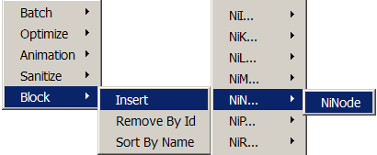
- At the end, insert a new NiNode.
Name it as the Root Node (the BSFadeNode) followed by a space and the suffix NonAccum.
Here that would be: TerminalInterface01 NonAccum
(This seems to be a naming convention, not formally needed to make things work. Better to leave it this way and stay on the safe side).
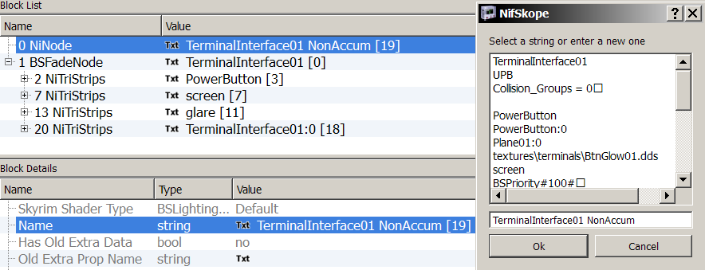
- Click on the Txt Value to access the String pop up window.
1A. Making all the NiTriStrips a child of the new NiNode.
- Choose the number of child you want in Num Children, update.
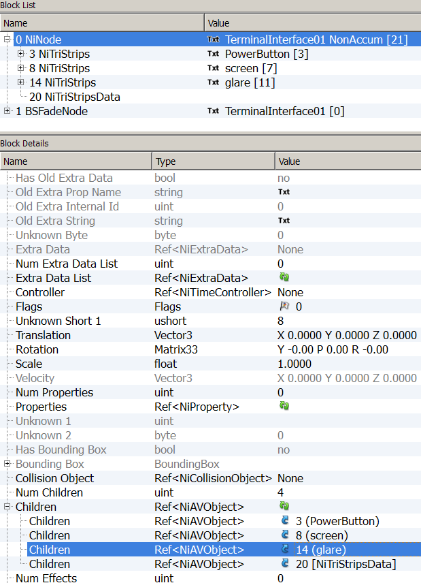
- Insert the Value of the four NiTriStrips.
- 1B. Making the NiNode the only child of the Root Node.
Select the Root Node.
- Change the Num Children to 1, update.
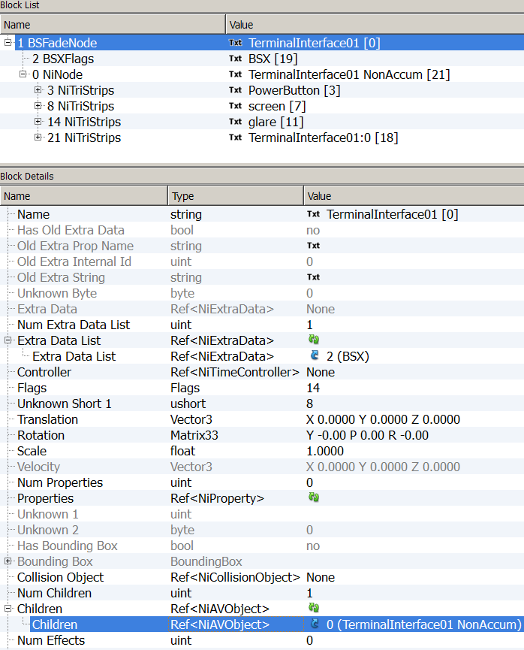
- Insert the Value of the NiNode in the Children Value field.
Time to save your work to allow blocks reorganisation.
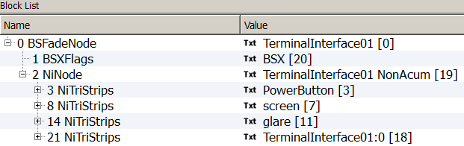
You should have now a structure like this:
If you open it in Geck now, you won’t notice any difference with the starting one.
It is just an internal organisation. However, this base structure is needed to build the animation.
- Inserting a NiControllerManager.
- Select the Root Node, and then Block  Insert  NiC  NiControllerManager.
- Adjust settings as following:
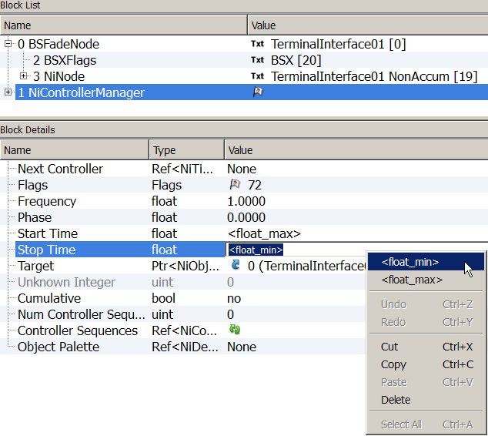
Right-click the value field to access these settings
Flags: 72 for looping, 76 for clamp animation
Frequency: 1.0000
Start time: <Float_Max>
Stop Time: <Float_Min>
Target: should be 0 as it references your Root Node
The actual length of the animation will be set later on other nodes.
We will take care of the Controller Sequences on a later step.
The next step will be to supply an Object Palette to the NiControllerManager.

The Object Palette will list all the NiNodes, NiTriStrips and other blocks contained in your Nif, even the Root Node.
Except for Collision Objects, only those are left out the Object Palette.
- Inserting a NiDefaultAVObjectPalette.
- Select the Controller then, Block  Insert  NiD  NiDefaultAVObjectPalette.
- Figure out how many objects you’ll need to add to the list, insert that number in the Num Objs Value field, update array.
- Reference each of your blocks by inserting their value in the AV Object Value field.
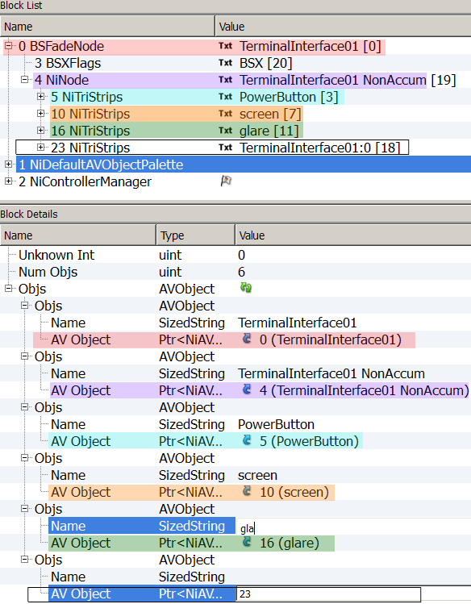
- Insert the string-name in the Name Value field. No typo allowed!
Naming
Object Value

This list can be extended later if need be.
- Once your Object Palette is completed, attach it to the NiControllerManager.
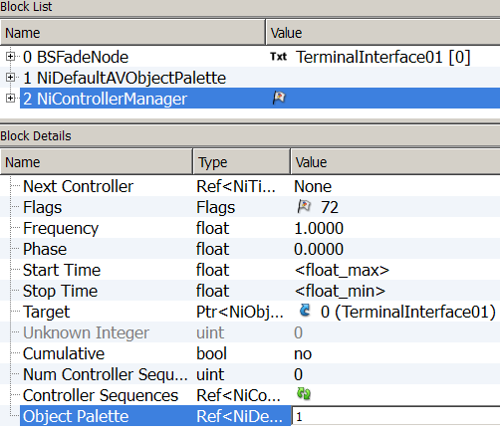
A new controller will be added now, the NiMultiTargetTranformController.
- Block  Insert  NiM  NiMultiTargetTranformController.
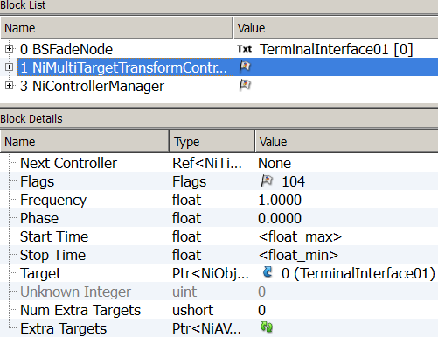
- Adjust settings as following:
Flags: 104
Frequency: 1.0000
Start time: <Float_Max>
Stop Time: <Float_Min>
Target: should be 0 as it references you Root Node

- In Num Extra Targets Value field, insert the number of NiNodes and NiTriStrips contained in your nif. That should be the same as in the NiDefaultAVObjectPalette.

The following instructions differ from TrickyVein’s tutorial (about object animation).
They are given according my experience, based on the inspection of quite a few nif with texture animations.
They are, at least, valid as far as Material and Textures animation are concerned.
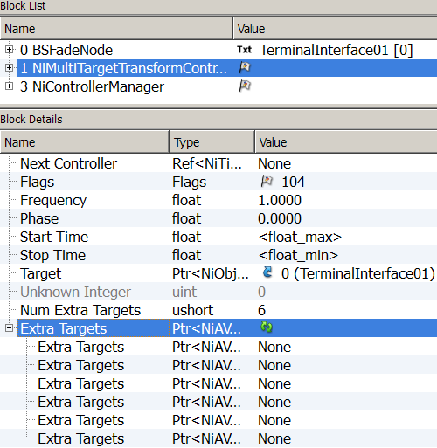
There is no need to name them here (although, it is safe to do it). As long that the declared Objects/Extra Targets numbers are corresponding.
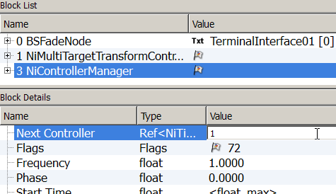
- Linking the NiMultiTargetTranformController to NiControllerManager.
- Linking the NiControllerManager to the Root Node.
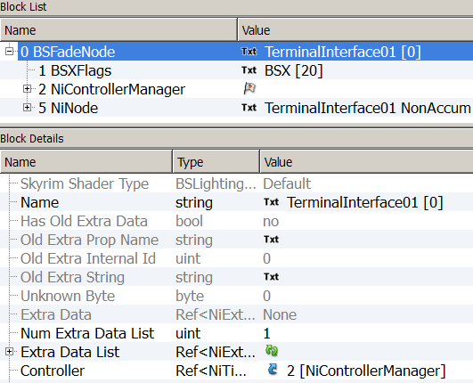
- In the Root Node, set the NiControllerManager as the Controller.

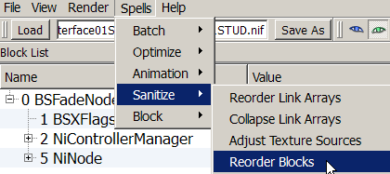
Save your work to let blocks reorganize or use Spell  Sanitize  Reorder Blocks.
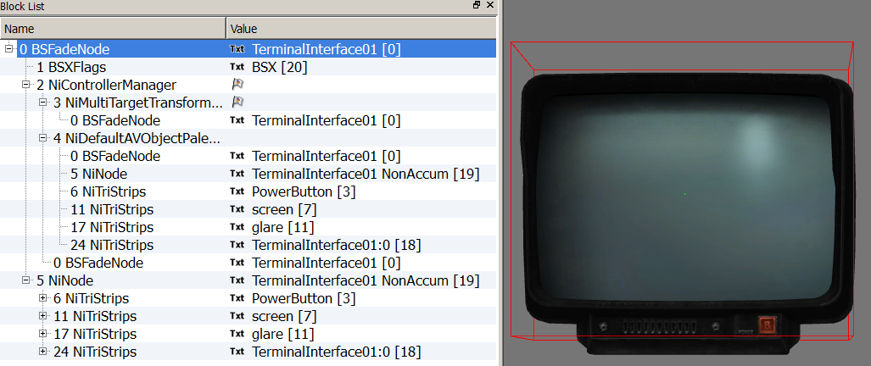
This should be the result at this stage. Don’t open in Geck as it will crash.
Actually, you won’t be able to check your progress in Geck before a long series of manipulations.
So, get coffee supplies, take a deep breath and let’s start the Sequence building process:
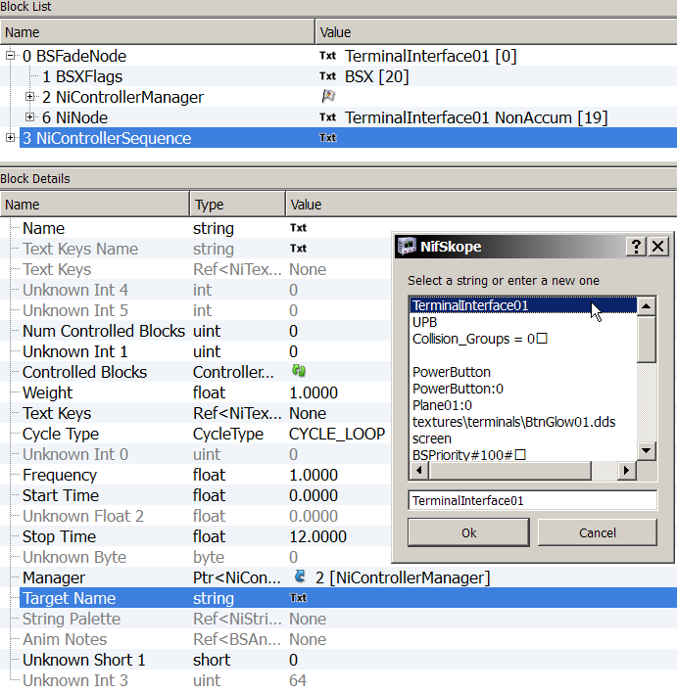
Sequence building
0.0000
Click to access the string list.
The Root name should be the first on the list.
We will need two sequences, both similar in their structure and containing the same type of animation. It means that we can create one sequence and duplicate it at a certain point to save some work.
- Inserting Sequence.
Select your NiControllerManager, then
Block  Insert  NiC  NiControllerSequence.
- Configuring NiControllerSequence.
We will set the parameters common to both sequences.
Cycle Type: CYCLE-LOOP
Frequency: 1.0000
Start time: 0.000
Manager: Value of the NiControllerManager
Target Name: Name of the Root Node
Each Controller Sequence has a Text Data that defines Start and Stop times, along with the possibility of triggering sounds at certain point.
- Inserting a NiTextKeyExtraData.
- Select the NiControllerSequence, then:
- Block  Insert  NiT  NiTextKeyExtraData.
- Setting the NiTextKeyExtraData number of keys.
- Select the NiTextKeyExtraData. Choose the number of Text key you want. (Here it would be 2). Update.
- Enter the string “start” without quotes in the first Value Value field. (click on Txt to access to String pop up window.)
- Enter the string “end” without quotes in the last Value Value field.
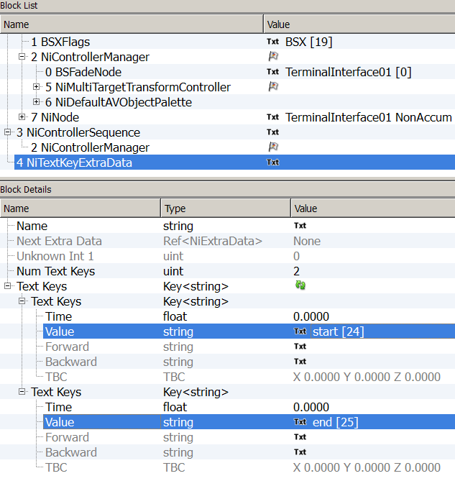
The Time Values be set later individually.

This is also the place where you can trigger sound in your animation. You can start a sound but you cannot stop it. So, if you trigger a looped sound, it will play forever and, each time you activate the sequence a new occurrence of the sound will start and stack up.
Use non looping sound.
Add a key between start and end, choose your time of triggering and set the Value as:
Sound: NameOfTheSound
Where NameOfTheSound is either an existing name of a sound referenced in Geck or the name of a sound you’ve created in Geck.
Linking the NiTextKeyExtraData to the NiControllerSequence.
- In the NiControllerSequence, set the Value of the NiTextKeyExtraData in the Text Keys Value.
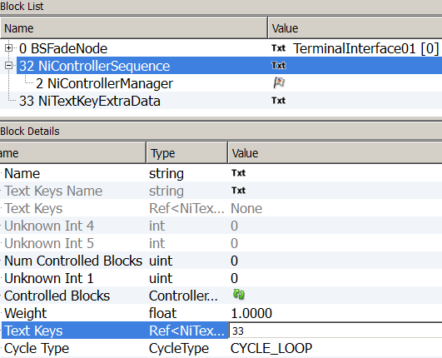
This is the basics of the sequence structure. You might want to save your work now as it can be a starting point for variations. (Although mesh is not usable as it is and will crash in the Geck.)
We will go further with this process, by building animation block inside the sequence.
Four blocks will be built:
- One Alpha animation for future (in)visibility,
- One Emissive animation
- Two translate animations: U and V (for panning when ON and fixed when OFF).

Building animation blocks within a sequence
It is easier to define the blocks before being building them. You will need four Controlled Blocks in total, but for the clarity of the process, we will build each one by one and add them to the sequence one at the time.
- Defining the animation blocks.
1A. Select the NiControllerSequence, in block details: Set the Num Controlled Blocks to 1.
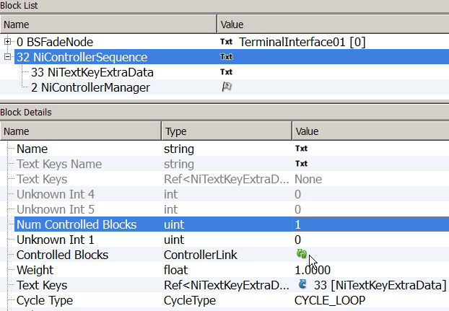
Update.

1B. Expand Controlled Blocks.
In Node Name: Select the name of the NiTriStrips you’re planning to animate.
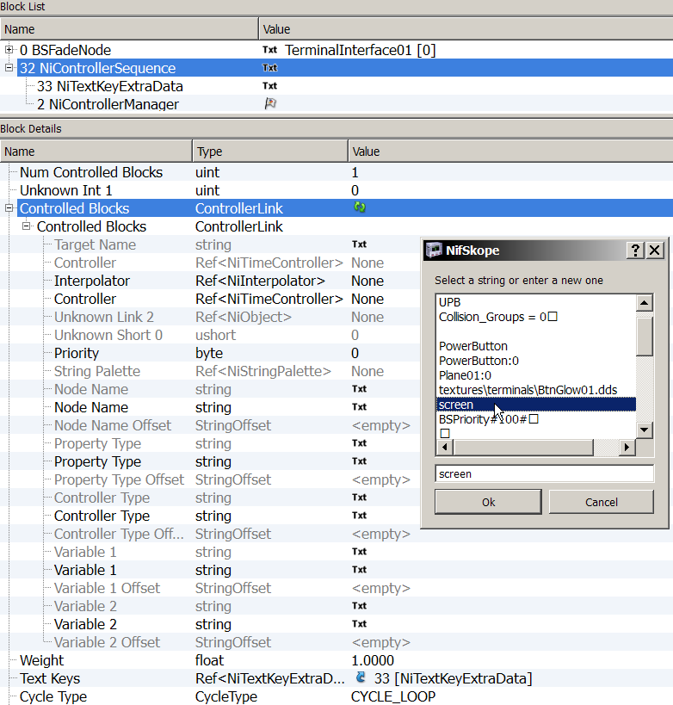
Click on the Txt to access the string window.
1C. Define the property you’re going to animate.
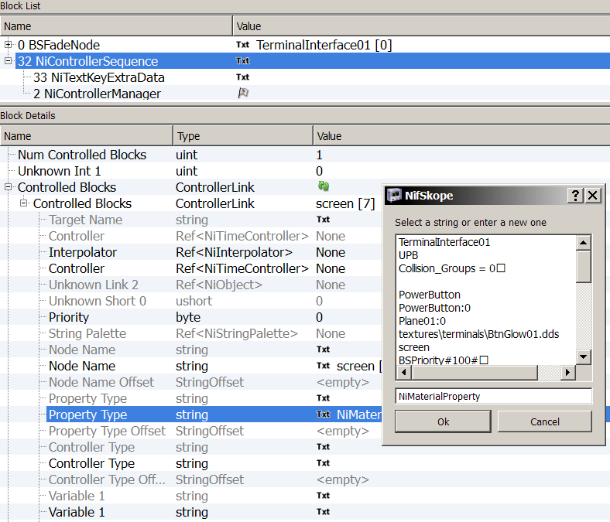
In Property Type Value insert the following string: NiMaterialProperty
1D. Define the Controller type you’re going to use.
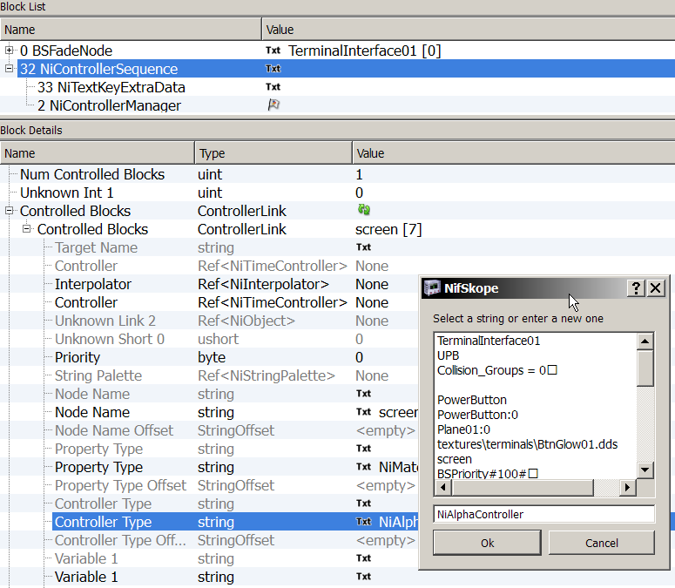
In Controller Type Value insert the following string: NiAlphaController
Let’s start by building an Alpha Animation Block
- Building an Alpha animation block. Select the NiControllerSequence.
You will need to insert four elements.
  - A NiAlphaController:
Block  Insert  NiA  NiAlphaController
  - A NiBlendFloatInterpolator:
Block  Insert  NiB  NiBlendFloatInterpolator
  - A NiFloatInterpolator:
Block  Insert  NiF  NiFloatInterpolator
  - A NiFloatData:
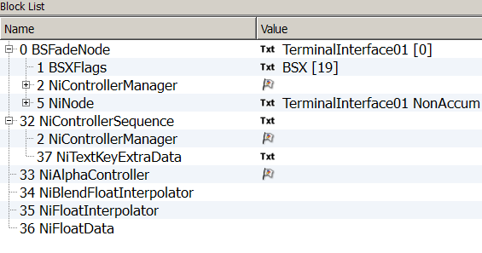
Block  Insert  NiF  NiFloatData
- Linking the elements.
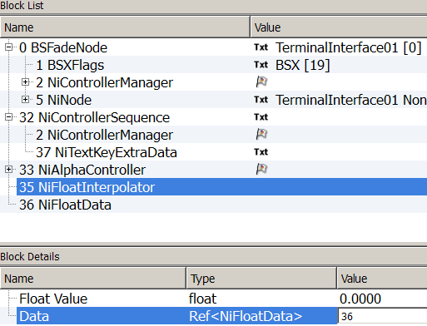
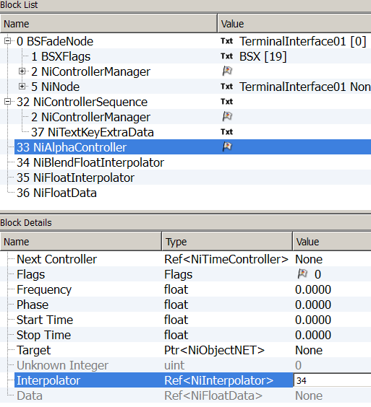
The NiBlendFloatInterpolator will be linked to the NiAlphaController.

The NiFloatData will be linked to the NiFloatInterpolator.

- Adjusting the settings.
The NiAlphaController:
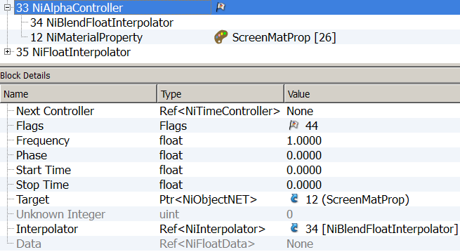
Flags | 40 for loop, 44 for Clamp
Frequency | 1.0000
Target | The NiMaterialProperty of the NiTriStrips you’re animating

The NiBlendFloatInterpolator:
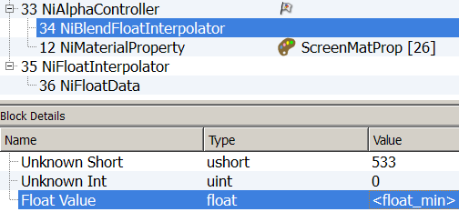
513
Unknown Short | 513
Float Value | <float_min>
The NiFloatInterpolator:
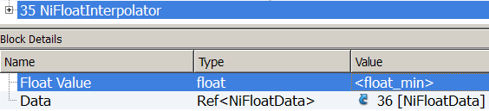
Float Value | <float_min>
The NiFloatData (the keys) will be set later.
These two sub-blocks (Controller and Interpolator) will be referenced inside the NiControllerSequence.
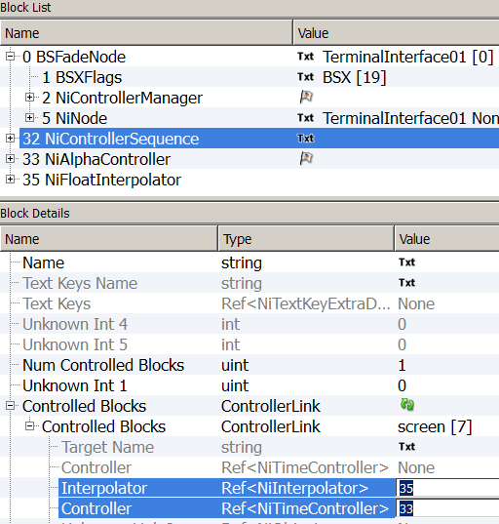
- Select the NiControllerSequence; go to your Controlled Blocks and insert the values of the NiAlphaController and the NiFloatInterpolator in their respective Value Fields.
After blocks reorganisation, you should have this result:
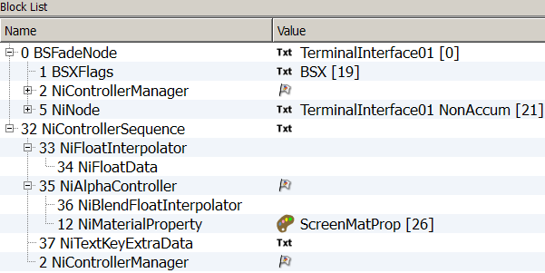
an Alpha animation block inside a sequence.
Let’s go further and build an emissive animation block for the Power Button.
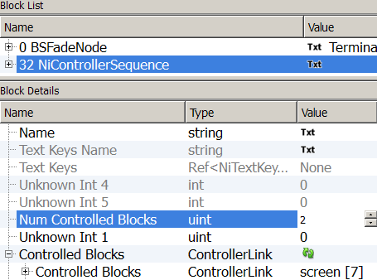
- Go to the NiControllerSequence, in block details: increase the Num Controlled Blocks from 1 unit. Update.

- Expand and define the new controlled block.
- In Node Name: enter the name of the NiTriStrips you’re planning to animate.
- In Property Type Value insert the following string: NiMaterialProperty
- In Controller Type Value insert the following string: NiMaterialColorController
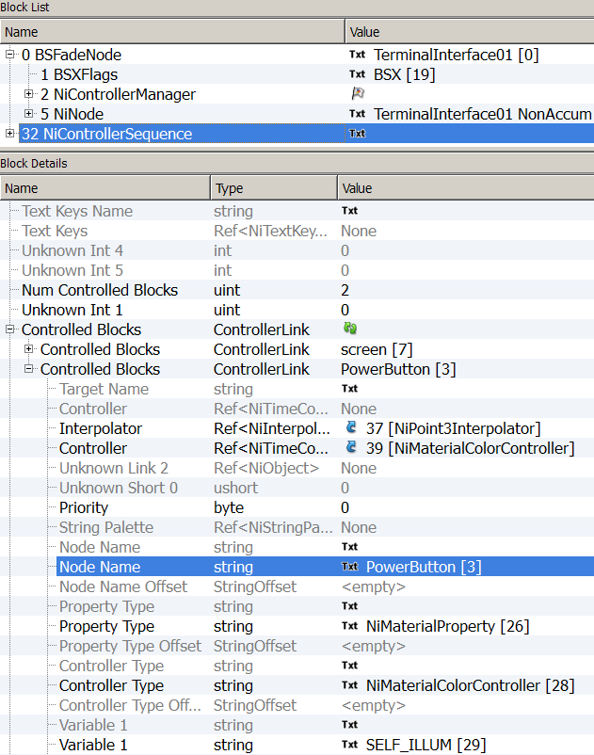
- In Variable 1 Value Insert SELF_ILLUM string.

- Building an Emissive animation block, four elements needed.
A NiMaterialColorController
A NiBlendPoint3Interpolator
A NiPoint3Interpolator
A NiPosData
For some reason I never manage to set the NiBlendPoint3Interpolator and the NiPoint3Interpolator parameters to <Float_Min> the usual way.
So the workaround would be to copy these, correctly set, from another mesh.
Open DemoCameraMonitor.nif in a second occurrence of Nifskope. Locate a NiBlendPoint3Interpolator and a NiPoint3Interpolator, any one will do.
Follow these steps:
A. In your mesh: Block  Insert  NiM  NiMaterialColorController
B. In the 2nd mesh: NiBlendPoint3Interpolator  Block  Copy
In your mesh:  Block  Paste
C. In the 2nd mesh: NiPoint3Interpolator  Block  Copy
In your mesh:  Block  Paste (this one may retain a Data Value from the base mesh, don’t bother, you’ll change that the next step)
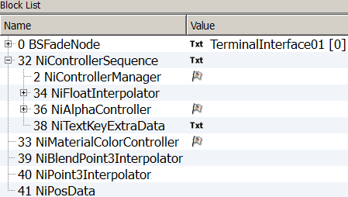
D. In your mesh: Block  Insert  NiP  NiPosData
- Linking the elements. (Just as we did previously, point 3).
- The NiBlendPoint3Interpolator will be linked to the NiMaterialColorController.
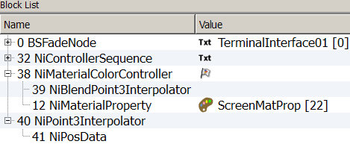
- The new NiPosData will be linked to the NiPoint3Interpolator.
Reorder blocks with Spells  Sanitize  Reorder Blocks.

- Adjusting the settings.
The NiMaterialColorController.
Flags | 108
Frequency | 1.0000
Target | The NiMaterialProperty of the NiTriStrips you’re animating
Target Color | TC_SELF_ILLUM
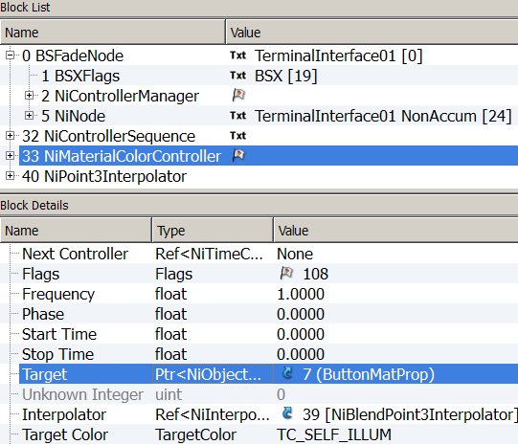
The NiBlendPoint3Interpolator.

Unknown Short | 513
Point Value | X <float_min> Y <float_min> Z <float_min>
The NiPoint3Interpolator

Point 3 Value | X <float_min> Y <float_min> Z <float_min>
Both should be correctly set from copy.
The NiFloatData (the keys) will be set later.
Again these two sub-blocks (Controller and Interpolator) need to be referenced inside the NiControllerSequence. (Like in step 5)
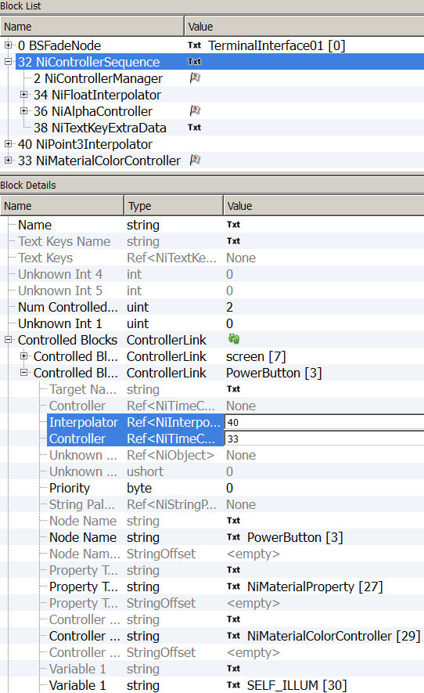
- In the NiControllerSequence; go to your new Controlled Blocks and insert the values of the NiMaterialColorController and the NiPoint3Interpolator in their respective Value Fields.
And finally let’s build an UV Translate Animation Block, for the screen.
Two blocks are needed (one for U, one for V), since their structure is the same, apart from one setting, we can build one, duplicate it and set the respective settings after.
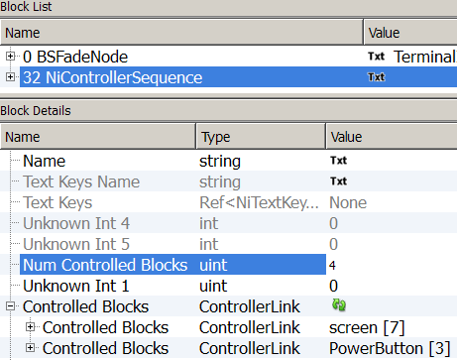
- Go to the NiControllerSequence, in block details: increase the Num Controlled Blocks from two units. Update.
- Define the two new controlled blocks.
- In Node Name: enter the name of the node you’re planning to animate.
- In Property Type Value insert the following string: NiTexturingProperty
- In Controller Type Value insert the following string: NiTextureTransformController
In the first new Controlled Bock enter 0-0-TT_TRANSLATE_U in the Variable 1
In the second Controlled Block enter 0-0-TT_TRANSLATE_V in the Variable 1 (as pictured).
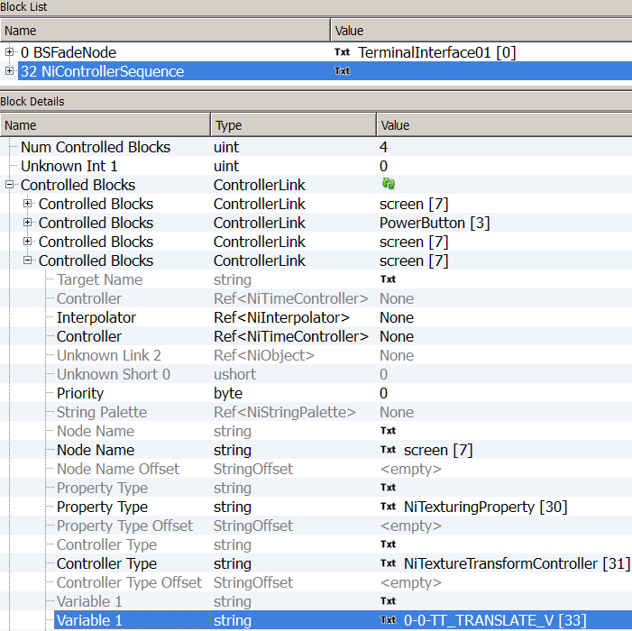
- Building an UV animation block. Again, you will need to insert four elements:
A NiTextureTransformController:
Block  Insert  NiT  NiTextureTransformController
A NiBlendFloatInterpolator:
Block  Insert  NiB  NiBlendFloatInterpolator
A NiFloatInterpolator:
Block  Insert  NiF  NiFloatInterpolator
A NiFloatData:
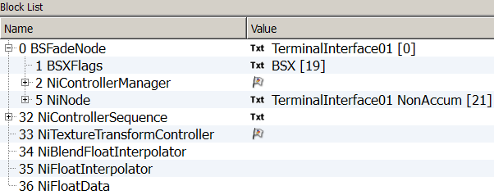
Block  Insert  NiF  NiFloatData
- Linking the elements.
The NiBlendFloatInterpolator will be linked to the NiTextureTransformController.
The NiFloatData will be linked to the NiFloatInterpolator.
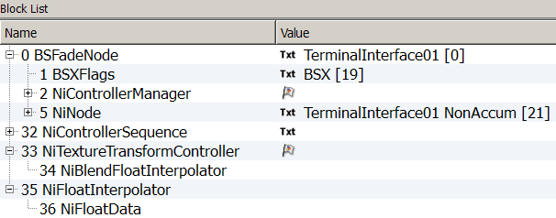
- Adjusting the settings.
NiTextureTransformController:
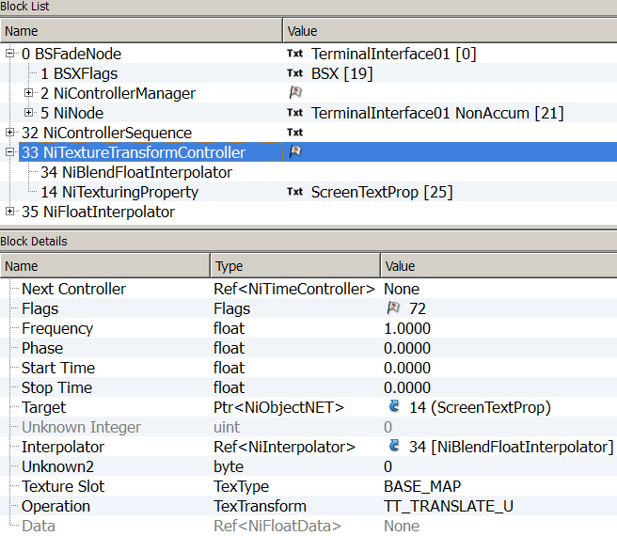
Flags | 72
Frequency | 1.0000
Target | The NiTexturinglProperty of the NiTriStrips you’re animating
The NiBlendFloatInterpolator:
Unknown Short | 513
Float Value | <float_min>
The NiFloatInterpolator:
Float Value | <float_min>
Data keys and Operation Type will be set later.
Since we want Two Texture Transform blocks (U & V), we can use the duplicate function and make a second set of block out of the one we have just built.
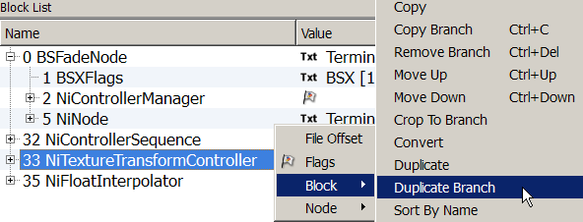
- Select the NiTextureTransformController then right click Block  Duplicate Branch.

- Same with the NiFloatInterpolator.
Select the NiFloatInterpolator then right click Block  Duplicate Branch.
- Let’s adjust the specific settings of the second NiTextureTransformController.
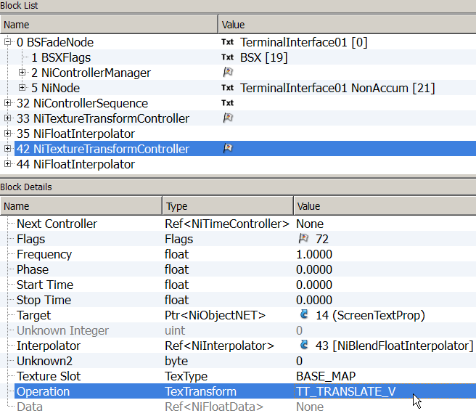
Set the Operation Value to TT_TRANSLATE_V

The first NiTextureTransformController should be on TT_TRANSLATE_U by default.
We will now reference these sub blocks in the sequence. (Like we did in step 5 and 11.)
- Select the NiControllerSequence. Go to the third Controlled Block.
The U Controlled Block
- As Interpolator set the value of the first of the two NiFloatInterpolator you’ve created.
- As Controller set the value of the first of the two NiTextureTransformController you’ve created.
The V Controlled Block
- As Interpolator set the value of the second NiFloatInterpolator you’ve created.
- As Controller set the value of the second NiTextureTransformController you’ve created.

Illustration for the U Controlled Block.
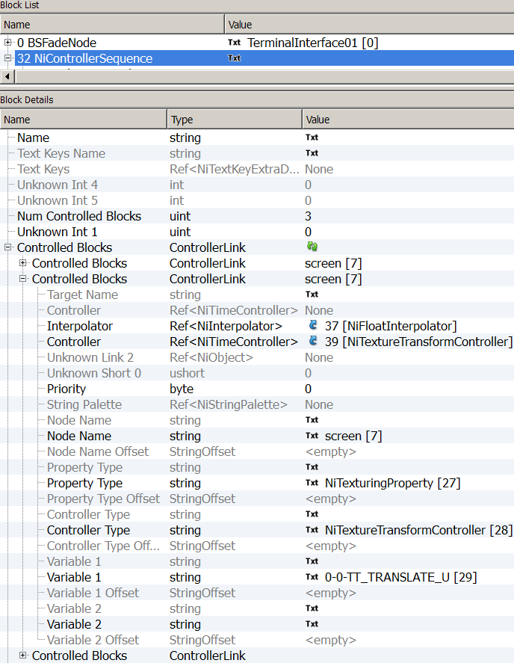
- Link the two Translate NiTextureTransformController together as they act as a pair.
In block List, expand the NiControllerSequence and
- Select the first of your NiTextureTransformController.
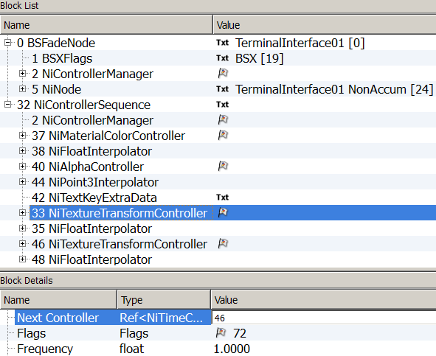
- Set the value of the second NiTextureTransformController as Next Controller.
Reorder Blocks. (Spells -> Sanitize -> Reorder blocks)
You should now have one unnamed NiControllerSequence, containing four Controlled Blocks:
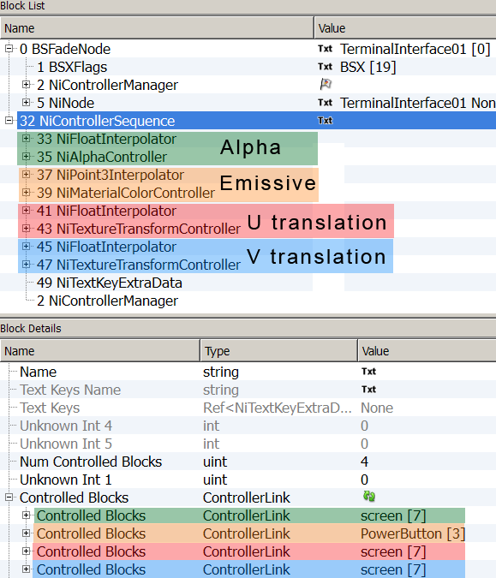
One Alpha animation block, one Emissive animation block, one Translate U animation block and one Translate V.

You will need to link the different Material and Texturing Properties to their respective Controllers.
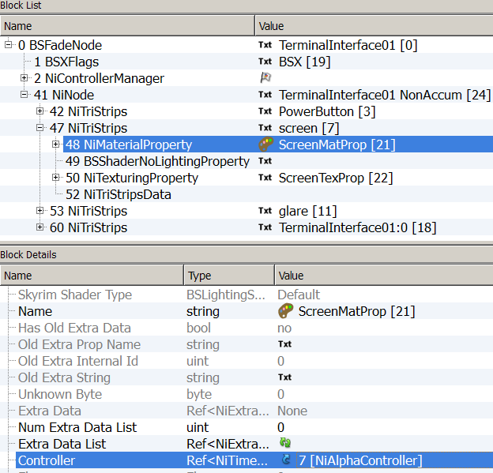
- Go to the NiMaterialProperty of the Screen NiTriStrips, set the NiAlphaController as Controller.
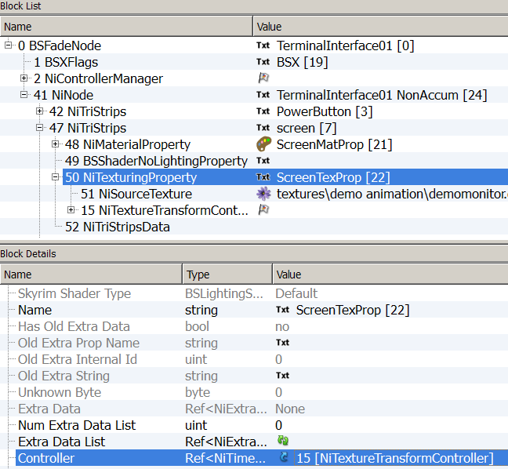
- Go to the NiTexturingProperty of the Screen, set the first NiTextureTransformController as Controller.
- Go to the NiMaterialProperty of the PowerButton, set the NiMaterialColorController as Controller.
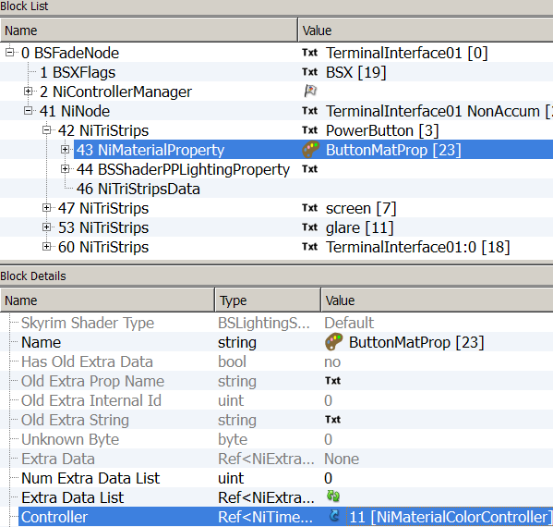
If you plan to use more animation blocks that will take place in both sequences, you can add it now, following the same steps.
If you are confident enough to have all the animations needed and all the settings correctly set you can duplicate the sequence.
As said before, the names given to the sequences do matter; they are related to script triggering.

Those of interest for us now are: Forward and Backward.

Duplicating sequence
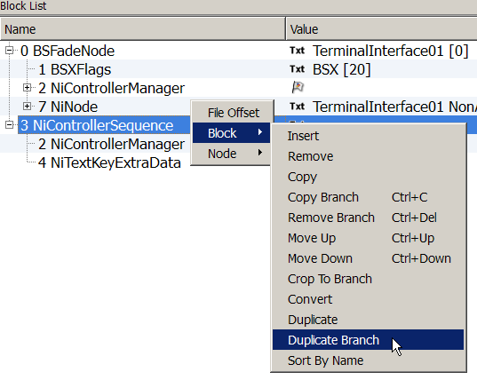
Since there is more than one element, we will use Duplicate Branch.
- Select the NiControllerSequence then, Block  Duplicate Branch.
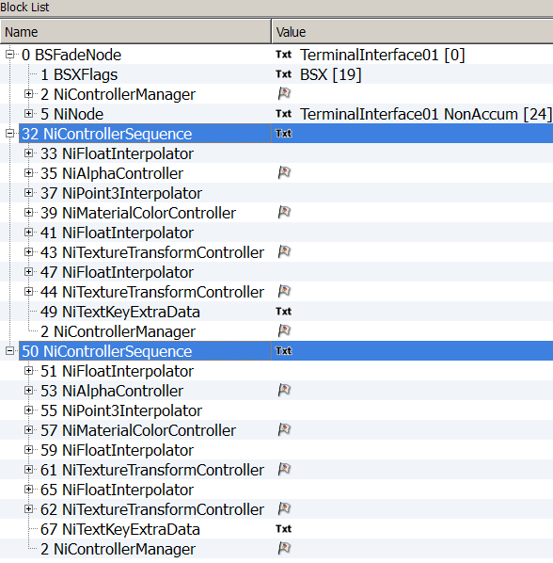
This should be the result at this stage.

- Defining the two different NiControllerSequence.
- Select the first NiControllerSequence.
- Enter the String-Name: Forward (Forward will be played by default, in games).
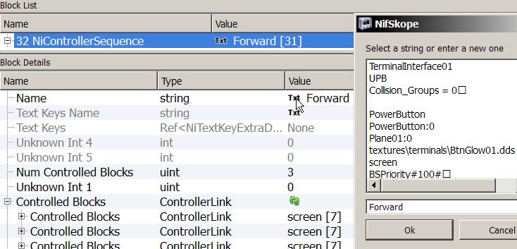
- Select the second NiControllerSequence.
- Name it Backward
- Attaching the two sequences to the NiControllerManager.
- Select the NiControllerManager.
- Set the number of sequences in the Num Controller Sequences (2). Update.
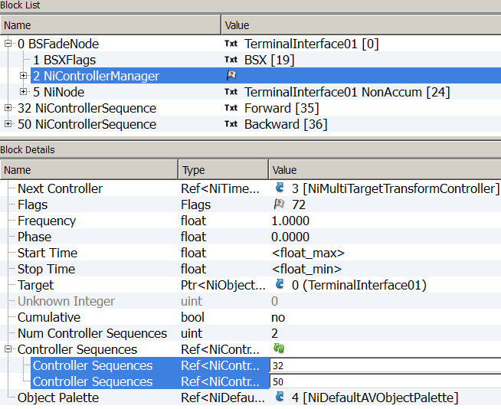
- Link the two sequences.
Save.
At this point you can check in Geck preview if your structure is stable.
It might be a good starting point for variations, as now, the remaining work will only be setting times and events.
Time and Keys Settings
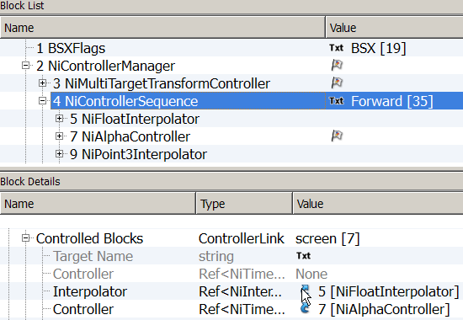
Let’s start with the Alpha animation of the first sequence, the Forward one.
- Finding of the NiFloatData corresponding to the NiAlphaController.
- Select the first of the Controlled blocks (the Alpha one) and expand it.
- Click on the blue arrow of the Interpolator.

You will be transported to it.
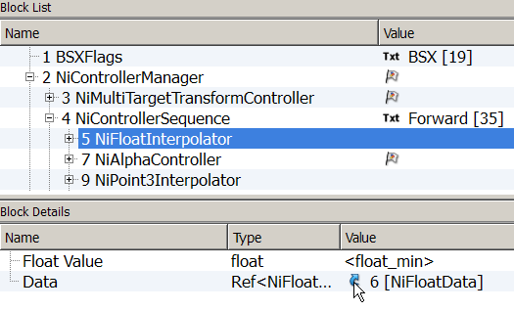
- Same there, click on the blue arrow to go to the Data.
Again, this is the safest way to navigate in your structure.
You can also find the Data by looking at the structure and reading its pattern.
Above each Controller is the Interpolator related to it in the Sequence.
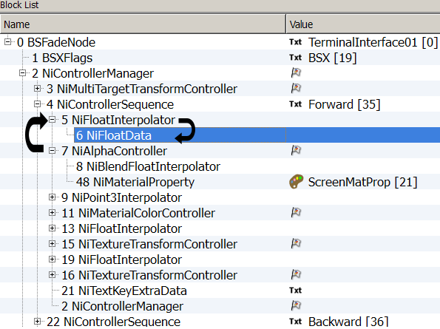
Linked to it is the Data with the keys.
Alpha animation block
Any ways, you’ve ended up in the NiFloatData of the Alpha Controller.
- Setting the keys of the Alpha Controller - Sequence Forward.
- Choose the number of keys = 1
- Set the interpolation to CONST_KEY
- Set the Key Value to 1
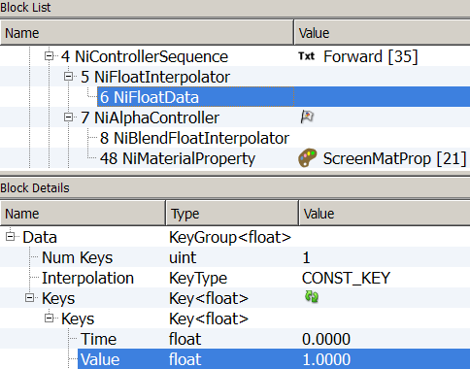
- Setting the keys of the Material Controller - Sequence Forward.
Locate the NiPosData related to the Material Controller.
- Number of key = 1
- Set the interpolation to CONST_KEY
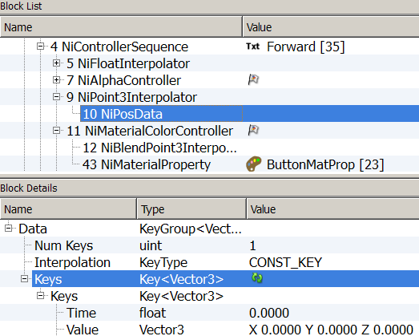
- Leave the Time and Value to 0 as it will be the unlit state of the button.

- Setting the keys of the NiTextureTransformController U - Sequence Forward.
- Locate the NiFloatData related to the NiTextureTransformController U.
- Choose the number of keys = 1
- Set the interpolation to CONST_KEY
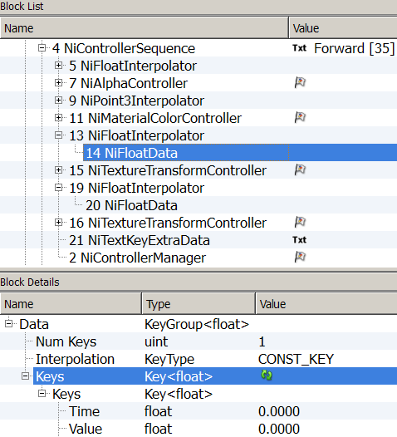
- The Time and Value will be left at 0
- Setting the keys of the NiTextureTransformController V - Sequence Forward.
- Locate the NiFloatData related to the NiTextureTransformController V.
- Choose the number of keys = 1
- Set the interpolation to CONST_KEY
- The Time and Value will be left at 0
Last element to be adjusted for the forward sequence: the NiTextKeyExtraData.
Actually, in this case the NiTextKeyExtraData is all set up from our previous steps (point 4 of Sequence Building – page 17).
- Setting of the NiTextKeyExtraData - Sequence Forward.
- Select the NiTextKeyExtraData. (Should be found at the end of the sequence.)
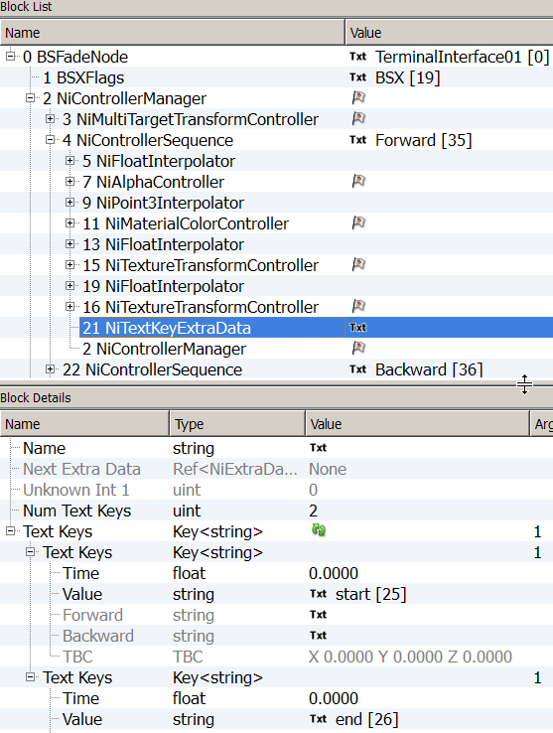
- Check the settings.

You have now one functional Forward-OFF sequence with four animation blocks.
The Alpha block will maintain visibility of the Screen.
The Material Color block will set the Button unlit.
The Translate U block
will place and keep the Screen texture up left .
The Translate V block

The steps to set the Backward sequence will be the same, only the parameters values will differ.
- Select the NiControllerSequence Backward.
- Set the stop time to 24 (24 seconds is the time a camera take to make its panning animation).
- Setting the keys of the Alpha Controller - Sequence Backward.
- Locate the NiFloatData related to the NiAlphaController.
- Choose the number of key (1)
- Set the interpolation to CONST_KEY
- Set the Key Value to 1
- Setting the keys of the NiMaterialColorController.
- Locate the NiPosData related to the NiMaterialColorController.
- Choose the number of key (1)
- Set the interpolation to CONST_KEY
- Set the key Values to X 0.9000 Y 0.9000 Z 0.9000
- Setting the keys of the NiTextureTransformController U - Sequence Backward.
Key | Time | 0.0000
Key | Value | 0.5000
Key | Time | 1.0000
Key | Value | 0.5000
Key | Time | 5.0000
Key | Value | 0.0000
Key | Time | 7.2000
Key | Value | 0.0000
Key | Time | 11.0000
Key | Value | 0.5000
Key | Time | 12.2000
Key | Value | 0.5000
Key | Time | 16.0000
Key | Value | 0.0000
Key | Time | 18.2000
Key | Value | 0.0000
Key | Time | 22.0000
Key | Value | 0.5000
Key | Time | 23.0000
Key | Value | 0.5000
- Locate the NiFloatData related to the NiTextureTransformController U.
- Choose the number of key (10)
- Set the interpolation to LINEAR_KEY
- Set the Time and Value as following:

- Setting the keys of the NiTextureTransformController V - Sequence Backward.
- Locate the NiFloatData related to the NiTextureTransformController V.
- Choose the number of key (1)
- Set the interpolation to LINEAR_KEY
- Set the Value to 0.5000
- Setting of the NiTextKeyExtraData - Sequence Backward.
- Select the NiTextKeyExtraData. (should be found at the end of the sequence)
- Enter 24.0000 in the “end” Time Value.
Save.

Congratulations!
You have now a fully functional nif with two sequences triggering four animation blocks each.
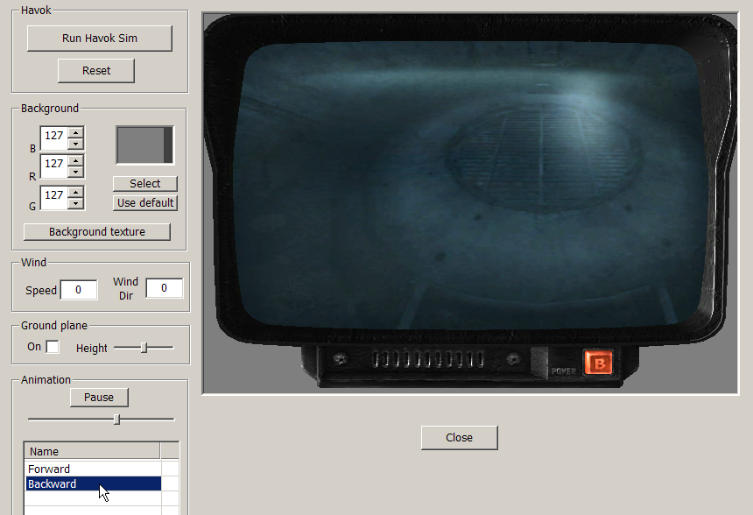
The NifSkope preview doesn’t give justice to your hard work, open it in Geck preview.
Select your sequence

It’s a nice base, but it could certainly be improved!
For example, the Glare is a nice touch when the monitor is OFF, but might be distracting when ON.
Since the present Alpha Block Animation is not really active, you could make use of it to set the Glare invisible at ON state and visible at OFF state.
The procedure would be for both Sequences:
- Select the Alpha Controlled Block, change the Node Name to Glare
- Adjust the Keys in the NiFloatData (1 in Forward Sequence, 0 in Backward)
Then, in the Material Property of the Glare, Select the first Alpha Controller as Controller and delete it in the Material Property of the screen.

Or you may want to add some images jumps with the UV Translate.
You may want to animate the Glare with scan lines.
These examples can be seen in the DemoCameraMonitor.nif.

It’s time for you to test and play!

Script
If you make an activator based on the monitor nif you’ve just built and attach a script to it, you would be making the Player able to trigger the ON/OFF states in game.
The PlayGroup command plays an animation group on the calling actor.
The AnimGrpoups have specific names.
See AnimGroups for a list of possible animations. http://geck.bethsoft.com/index.php?title=AnimGroups
A flag must be used to control initialization of the group.
0 = Normal - The current animation will finish its full cycle, and the new animation will start from its beginning.
1 = Immediate Start - The current animation will stop regardless of the frame it is on, and the new animation will start from its beginning.
2 = Immediate Loop -The current animation will stop regardless of the frame it is on, and the new animation will start at the beginning of its loop cycle.

Here is a short script to switch ON & OFF the monitor (or any other nif with two sequences).
Scn MyMonitorPlayScript

Short MonitorOn ; 0 = off, 1= on
Begin OnActivate
Activate
if MonitorOn == 0
Playgroup Backward 0
Set MonitorOn to 1
else
Playgroup Forward 0
Set MonitorOn to 0
endif
End

This is of course the basics; it can be extended and adapted to your need.
Troubleshooting check list
Error message when trying to copy branch. | Are the NiMaterialProperty and NiTexturingProperty properly named?
Rotating texture is not centered. | In the NiTexturingProperty, adjust Center Offset setting of the Base Texture section. (Part 3, page 11)
Animated texture is acting weird. (reversed, random, ...) | Check Transform Type? in the Base Texture section of the NiTexturingProperty. (Part 3, page 7)
The Time setting doesn’t work. | With a Controller Manager, Time is set in three places:  in the NiControllerSequence, the NiTextKeyExtraData, (these need to match), and in the Texture or Material Controllers itself (those can be shorter or equal to the general length set above).
The object can’t be activated in game. | Is there a Collision Object in the mesh? BSXFlag Enable Collision checked?
Texture is not visible. | With a Controller Manager, texture need to be referenced twice: in the NiSourceTexture and in the BSShaderNoLightingProperty. (Part 3 Page 5)
Everything is set, but animation won’t start. | Is the Has Texture Transform set to Yes? (In NiTexturingProperty’s Base Texture settings) (Part 3 Page 6)
Everything is set, but animation won’t start. | Does the NiMaterialProperty or the NiTexturingProperty have their respective NiMaterialColorController or NiTextureTransformController referenced? (Part 2 Page 7 Point 8, Page 12 Point 9. - Part 3 Page 9 Point 8, Page 13 Point 8. - Part 4, Page 34)

Final note
I hope that this tutorial has given you a rough idea of what can be done with Material and Texture Animation and the possibility to do it yourself.
The potential is endless and the applicable fields are barely touched here.
Think of Special Fx, weapons, armors, etc.
I have tried my best to bring to light the structures and patterns as I have understood them.
My biggest reward would be that the tutorial becomes rapidly useless to you. Because you don’t need to follow a step by step instruction any more, you actually know what you are doing and why you are doing it.
And in case you are lost, go open some Vanilla meshes and inspects them in detail, the answer is there somewhere…

Some meshes of interest:
Base Game
Computerrack01.nif – in Clutter\consoles
Console02.nif – in Clutter\consoles
projectorlightfx01.nif – in Clutter\projector
radiowave.nif – in interface\radiowave
shishkebab.nif – in weapons\1handmeele
fxtesla.nif – in armor\powerarmor

DLC – Point Lookout

Dlc04tvmansionsecurity01.nif – in dlc04\Clutter

And of course, a masterpiece: Television Comes To Fallout by RazoWire.
http://www.nexusmods.com/fallout3/mods/14675/?
You have tools, now your only limitation is your imagination … and your time. Good luck!
If this has brought you some satisfaction, don’t hesitate to express it; a comment, an endorsement, a credit or Kudos gives a warm fuzzy feeling and encourages me to continue … ☺
Thank you.
Pixelhate. June 2014.

Credits (Alphabetic)
I would like to thank deeply and sincerely.
- Anoxeron for his dedication, enthusiasm and benevolence. Thank you for testing each exercise, each step without respite and for giving me countless opportunities to improve this tutorial. Thank you for proof reading and corrections.
http://www.nexusmods.com/fallout3/users/3694499/?
- BrettM for his tutorial about Textures Animations for Skyrim, despite a big difference in the engine, his tutorial was an inspiration for layout and presentation.
http://www.nexusmods.com/skyrim/mods/47104/?
- Ghogiel for his guide about NiMaterialControlers, his resources and mods which are real learning material and for his kind private answers about Specularity.
http://wiki.tesnexus.com/index.php/Adding_material_controllers_to_objects_in_Nifskope
http://www.nexusmods.com/fallout3/users/209926/?tb=mods&pUp=1
  - Nexus for hosting this.
http://www.nexusmods.com/fallout3/
- Prensa for her kindness, constant support and patient explanations. For sending me back faulty experiments, miraculously repaired and working. Her posts, on Nexus, can be compiled and will answer most of the troubles you’ll encounter in FO3. Thank you for proof reading and corrections.
http://www.nexusmods.com/fallout3/users/751212/?tb=mods&pUp=1
http://forums.nexusmods.com/index.php?/user/751212-prensa/
- Sullyvanj93 for partial proof reading and writing advices.
- TrickyVein for his very clear tutorial on NiControllerManager on Nexus which has helped me to tame “this intimidating beast” and understand the necessity to develop a workflow.
http://forums.nexusmods.com/index.php?/topic/984792-tutorial-working-with-the-nicontrollermanager/
- Turboscalpeur for his friendship, support and beautiful images.
http://forums.nexusmods.com/index.php?/user/4708873-turboscalpeur/
https://www.flickr.com/photos/turboscalpeur/
- Weijiesen for overall theory consistency scrutinizations and awesomeness!
http://www.nexusmods.com/newvegas/users/1026866/?tb=images&pUp=1
- The good people who takes time to write articles, tutorials, guides and make them available to others.
https://www.google.com
- The nice people helping on forums like Nexus, NifTools Forum, etc.
http://forums.nexusmods.com/
http://niftools.sourceforge.net/forum/
- The makers of The Elder Scrolls NifSkope guide for their very detailed guide offering the bases on what this tutorial is build
http://cs.elderscrolls.com/index.php?title=Working_With_Nifs_101_:_An_Introduction
http://cs.elderscrolls.com/index.php?title=Working_With_Nifs_101_:_Basic_Use
- The makers of the tools that allow us to express our creativity and share it.
NifSkope http://sourceforge.net/projects/niftools/files/nifskope/1.1.3/
Geck http://geck.bethsoft.com/index.php?title=Main_Page
Geck PowerUp http://www.nexusmods.com/fallout3/mods/15067/?

